**Tutorial 7 Embedded Systems**

Name: Date:

**Objectives**: *Be familiar with using thermistor (heat sensor) and LCD.*

Download the data sheet for LM35

1. Use of Heat sensor
2. Uses LCD
3. Calculation
4. Interfacing technique
5. More coding of ARDUINO Programming
6. Hardware connection

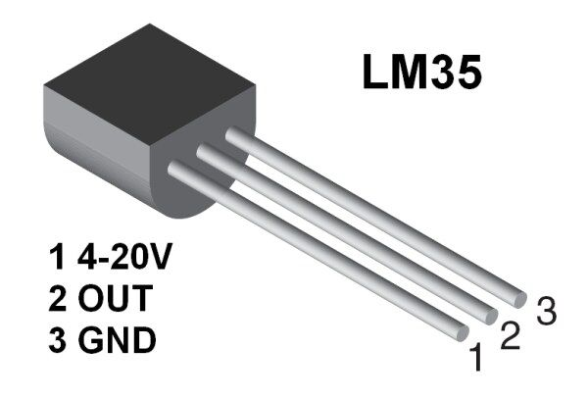

Figuure 1. Heat sensor LM35

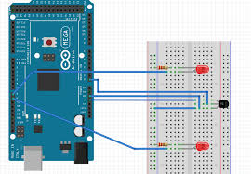

Figuure 2. Heat sensor LM35 connected to Arduino

**Material needed:**

1. Arduino Uno 2. Fan 3. LEDs (2) 4. LM35 5. LCD 6. Mini Solenoid

**Design Statement:**

An analogue temperature sensor, an air conditioner (A/C) and a fan are controller by an Arduino Uno microcontroller. The output state of some of the pins indicates the on/off state of A/C and fan. Only one of the output devices can be on at one time, when the A/C is on, the fan is off and when the fan is on, the A/C is off. A green LED represents the A/C and a yellow LED represents the fan. Design, write programme and test your circuit for the Arduino Uno microcontroller to control the desired temperature of an office based on the conditions below a, b and c. Check the number display caused by the LM35 and map the number which best suit your design. Assume the temperatures range from 0◦C to 32◦C. You need to calculate and do the proper mapping to represent the required temperature. You can round the numbers to the nearest whole number. The actual temperature of the office should display on the LCD monitor for both in Celsius and Fahrenheit degree. Your program needs to have FUNCTION for operation on each mentioned condition

Note: Assume the mini solenoid turn on and off the A/C unit.

a. if T> 24 ◦C turn on the LED, activate the solenoid (A/C) and off the fan.

b. if 22 ◦C <T<=24 ◦C turn on fan, the LED and deactivate solenoid (off the A/C).

c. if T<= 22◦C do nothing, both fan and A/C are off.

*Hint: You need to download the LCD library and practice the simple Hello the World.*

*You may need to use scan function to check Hex number of your LCD*

*// Set the LCD address to 0x27 for a 16 chars and 2 line display LiquidCrystal_I2C lcd(0x20, 16, 2);*

Completed? ______Yes _________No

Comment: